Milestone 1

Angel Waters

2022-06-05

# Data Loading and Cleanup

The necessary packages were loaded for the analysis.

library(ggplot2)  
library(tidyverse)

## -- Attaching packages --------------------------------------- tidyverse 1.3.1 --

## v tibble 3.1.6 v dplyr 1.0.8  
## v tidyr 1.2.0 v stringr 1.4.0  
## v readr 2.1.2 v forcats 0.5.1  
## v purrr 0.3.4

## -- Conflicts ------------------------------------------ tidyverse_conflicts() --  
## x dplyr::filter() masks stats::filter()  
## x dplyr::lag() masks stats::lag()

library(ggQC)

Load the pre-cleaned up data and subset further.

##Loading the DK raw data subset for further cleaning and visualizing the data.  
rawData <-   
 read_csv("SWANBaselineData_ProfessorKSubset (1).csv")

## New names:  
## Rows: 3302 Columns: 33  
## -- Column specification  
## -------------------------------------------------------- Delimiter: "," chr  
## (18): HBCHOLE0, MIGRAIN0, ANEMIA0, LISTEN0, TAKETOM0, CONFIDE0, HELPSIC0... dbl  
## (15): ...1, SWANID, AGE0, HSWRKHR0, HOSPSTA0, PULSE0, SYSBP10, DIABP10, ...  
## i Use `spec()` to retrieve the full column specification for this data. i  
## Specify the column types or set `show_col_types = FALSE` to quiet this message.  
## * `` -> `...1`

str(rawData)

## spec_tbl_df [3,302 x 33] (S3: spec_tbl_df/tbl_df/tbl/data.frame)  
## $ ...1 : num [1:3302] 1 2 3 4 5 6 7 8 9 10 ...  
## $ SWANID : num [1:3302] 10005 10046 10056 10092 10126 ...  
## $ AGE0 : num [1:3302] 48 52 51 45 48 51 46 47 46 47 ...  
## $ HBCHOLE0: chr [1:3302] "(1) No" "(1) No" "(1) No" "(1) No" ...  
## $ MIGRAIN0: chr [1:3302] "(1) No" "(1) No" "(1) No" "(1) No" ...  
## $ ANEMIA0 : chr [1:3302] "(1) No" "(1) No" "(2) Yes" "(2) Yes" ...  
## $ LISTEN0 : chr [1:3302] "(5) All Of The Time" "(5) All Of The Time" "(4) Most Of The Time" "(5) All Of The Time" ...  
## $ TAKETOM0: chr [1:3302] "(5) All Of The Time" "(5) All Of The Time" "(4) Most Of The Time" "(5) All Of The Time" ...  
## $ CONFIDE0: chr [1:3302] "(5) All Of The Time" "(5) All Of The Time" "(4) Most Of The Time" "(5) All Of The Time" ...  
## $ HELPSIC0: chr [1:3302] "(1) None Of The Time" "(5) All Of The Time" "(5) All Of The Time" "(5) All Of The Time" ...  
## $ COMMITE0: chr [1:3302] "(1) No" "(2) Yes" "(2) Yes" "(2) Yes" ...  
## $ BOTHER0 : chr [1:3302] "(3) Occasionally/Mod Amt Of The Time (3-4 Days)" "(2) Some/A Little Of The Time (1-2 Days)" "(2) Some/A Little Of The Time (1-2 Days)" "(2) Some/A Little Of The Time (1-2 Days)" ...  
## $ APPETIT0: chr [1:3302] "(4) Most/All Of The Time (5-7 Days)" "(1) Rarely/None Of The Time (< 1 Day)" "(1) Rarely/None Of The Time (< 1 Day)" "(1) Rarely/None Of The Time (< 1 Day)" ...  
## $ BLUES0 : chr [1:3302] "(4) Most/All Of The Time (5-7 Days)" "(1) Rarely/None Of The Time (< 1 Day)" "(1) Rarely/None Of The Time (< 1 Day)" "(1) Rarely/None Of The Time (< 1 Day)" ...  
## $ KEEPMIN0: chr [1:3302] "(3) Occasionally/Mod Amt Of The Time (3-4 Days)" "(1) Rarely/None Of The Time (< 1 Day)" "(3) Occasionally/Mod Amt Of The Time (3-4 Days)" "(3) Occasionally/Mod Amt Of The Time (3-4 Days)" ...  
## $ DEPRESS0: chr [1:3302] "(4) Most/All Of The Time (5-7 Days)" "(1) Rarely/None Of The Time (< 1 Day)" "(1) Rarely/None Of The Time (< 1 Day)" "(1) Rarely/None Of The Time (< 1 Day)" ...  
## $ FAILURE0: chr [1:3302] "(3) Occasionally/Mod Amt Of The Time (3-4 Days)" "(1) Rarely/None Of The Time (< 1 Day)" "(1) Rarely/None Of The Time (< 1 Day)" "(1) Rarely/None Of The Time (< 1 Day)" ...  
## $ HAPPY0 : chr [1:3302] "(1) Rarely/None Of The Time (< 1 Day)" "(3) Occasionally/Mod Amt Of The Time (3-4 Days)" "(4) Most/All Of The Time (5-7 Days)" "(3) Occasionally/Mod Amt Of The Time (3-4 Days)" ...  
## $ HSWRKHR0: num [1:3302] 18 30 60 2 16 15 15 40 14 49 ...  
## $ HOSPSTA0: num [1:3302] 0 0 0 0 0 0 0 0 0 0 ...  
## $ SMOKERE0: chr [1:3302] "(1) No" "(2) Yes" "(1) No" "(2) Yes" ...  
## $ INCOME0 : chr [1:3302] "(2) $20,000 to $49,999" "(3) $50,000 to $99,999" "(3) $50,000 to $99,999" "(3) $50,000 to $99,999" ...  
## $ PULSE0 : num [1:3302] 36 38 36 32 40 41 33 30 35 31 ...  
## $ SYSBP10 : num [1:3302] 114 120 92 108 98 120 82 88 118 120 ...  
## $ DIABP10 : num [1:3302] 80 58 60 70 72 80 64 62 80 72 ...  
## $ HEIGHT0 : num [1:3302] 151 156 162 167 164 ...  
## $ WEIGHT0 : num [1:3302] 49.5 67.7 54.4 88.9 77.2 ...  
## $ HDLRESU0: num [1:3302] 40 57 76 44 45 51 76 65 41 87 ...  
## $ GLUCRES0: num [1:3302] 102 100 88 114 93 88 81 92 90 86 ...  
## $ INSURES0: num [1:3302] 7.2 13.7 4.3 26.8 11.3 14.7 5.5 9.6 46.1 8.8 ...  
## $ LDLRESU0: num [1:3302] 73 136 85 136 151 142 109 148 149 137 ...  
## $ TRIGRES0: num [1:3302] 122 138 75 85 57 233 75 96 157 71 ...  
## $ RACE : chr [1:3302] "(5) Hispanic" "(2) Chinese/Chinese American" "(4) Caucasian/White Non-Hispanic" "(4) Caucasian/White Non-Hispanic" ...  
## - attr(*, "spec")=  
## .. cols(  
## .. ...1 = col_double(),  
## .. SWANID = col_double(),  
## .. AGE0 = col_double(),  
## .. HBCHOLE0 = col_character(),  
## .. MIGRAIN0 = col_character(),  
## .. ANEMIA0 = col_character(),  
## .. LISTEN0 = col_character(),  
## .. TAKETOM0 = col_character(),  
## .. CONFIDE0 = col_character(),  
## .. HELPSIC0 = col_character(),  
## .. COMMITE0 = col_character(),  
## .. BOTHER0 = col_character(),  
## .. APPETIT0 = col_character(),  
## .. BLUES0 = col_character(),  
## .. KEEPMIN0 = col_character(),  
## .. DEPRESS0 = col_character(),  
## .. FAILURE0 = col_character(),  
## .. HAPPY0 = col_character(),  
## .. HSWRKHR0 = col_double(),  
## .. HOSPSTA0 = col_double(),  
## .. SMOKERE0 = col_character(),  
## .. INCOME0 = col_character(),  
## .. PULSE0 = col_double(),  
## .. SYSBP10 = col_double(),  
## .. DIABP10 = col_double(),  
## .. HEIGHT0 = col_double(),  
## .. WEIGHT0 = col_double(),  
## .. HDLRESU0 = col_double(),  
## .. GLUCRES0 = col_double(),  
## .. INSURES0 = col_double(),  
## .. LDLRESU0 = col_double(),  
## .. TRIGRES0 = col_double(),  
## .. RACE = col_character()  
## .. )  
## - attr(*, "problems")=<externalptr>

##Further subsets the data to meet the requirements for the final  
milestone1_subset <- subset(rawData, select = c(  
 SWANID,  
 AGE0,  
 ANEMIA0,  
 SMOKERE0,  
 PULSE0,  
 HEIGHT0,  
 WEIGHT0,  
 RACE)  
 )  
#view the different columns and their structures  
view(milestone1_subset)  
str(milestone1_subset)

## tibble [3,302 x 8] (S3: tbl_df/tbl/data.frame)  
## $ SWANID : num [1:3302] 10005 10046 10056 10092 10126 ...  
## $ AGE0 : num [1:3302] 48 52 51 45 48 51 46 47 46 47 ...  
## $ ANEMIA0 : chr [1:3302] "(1) No" "(1) No" "(2) Yes" "(2) Yes" ...  
## $ SMOKERE0: chr [1:3302] "(1) No" "(2) Yes" "(1) No" "(2) Yes" ...  
## $ PULSE0 : num [1:3302] 36 38 36 32 40 41 33 30 35 31 ...  
## $ HEIGHT0 : num [1:3302] 151 156 162 167 164 ...  
## $ WEIGHT0 : num [1:3302] 49.5 67.7 54.4 88.9 77.2 ...  
## $ RACE : chr [1:3302] "(5) Hispanic" "(2) Chinese/Chinese American" "(4) Caucasian/White Non-Hispanic" "(4) Caucasian/White Non-Hispanic" ...

Clean up the categorical data for data analysis and presentation.

milestone1_subset <- mutate(milestone1_subset, ANEMIA0=ifelse(ANEMIA0=="(1) No",  
 "No", ifelse(ANEMIA0=="(2) Yes", "Yes", NA)),  
 SMOKERE0=ifelse(SMOKERE0=="(1) No", "No", ifelse(SMOKERE0=="(2) Yes", "Yes", NA)),  
 RACE=ifelse(RACE=="(1) Black/African American", "Black/African American",  
 ifelse(RACE=="(2) Chinese/Chinese American",   
 "Chinese/Chinese American",  
 ifelse(RACE=="(3) Japanese/Japanese American",  
 "Japanese/Japanese American",  
 ifelse(RACE=="(4) Caucasian/White Non-Hispanic",   
 "Caucasian/ White Non-Hispanic",   
 ifelse(RACE=="(5) Hispanic", "Hispanic", NA)  
 )))))

# Descriptive Statistics

Calculating various descriptive statistics of each of the variables.

summary(milestone1_subset)

## SWANID AGE0 ANEMIA0 SMOKERE0   
## Min. :10005 Min. :42.00 Length:3302 Length:3302   
## 1st Qu.:31808 1st Qu.:44.00 Class :character Class :character   
## Median :54230 Median :46.00 Mode :character Mode :character   
## Mean :54362 Mean :45.85   
## 3rd Qu.:76745 3rd Qu.:48.00   
## Max. :99992 Max. :53.00   
## NA's :5   
## PULSE0 HEIGHT0 WEIGHT0 RACE   
## Min. :17.00 Min. :140.5 Min. : 37.60 Length:3302   
## 1st Qu.:32.00 1st Qu.:157.8 1st Qu.: 59.60 Class :character   
## Median :35.00 Median :162.4 Median : 70.60 Mode :character   
## Mean :35.19 Mean :162.4 Mean : 74.88   
## 3rd Qu.:38.00 3rd Qu.:167.0 3rd Qu.: 85.50   
## Max. :84.00 Max. :186.2 Max. :175.40   
## NA's :7 NA's :32 NA's :14

age_sd <- sd(milestone1_subset$AGE0, na.rm = TRUE)  
age_mean <- mean(milestone1_subset$AGE0, na.rm = TRUE)  
pulse_sd <- sd(milestone1_subset$PULSE0, na.rm = TRUE)  
pulse_mean <- mean(milestone1_subset$PULSE0, na.rm = TRUE)  
height_sd <- sd(milestone1_subset$HEIGHT0, na.rm = TRUE)  
height_mean <- mean(milestone1_subset$HEIGHT0, na.rm=TRUE)  
weight_sd <- sd(milestone1_subset$WEIGHT0, na.rm = TRUE)  
weight_mean <- mean(milestone1_subset$WEIGHT0, na.rm=TRUE)  
age_med <- median(milestone1_subset$AGE0, na.rm=TRUE)  
pulse_med <- median(milestone1_subset$PULSE0, na.rm=TRUE)  
height_med <- median(milestone1_subset$HEIGHT0, na.rm=TRUE)  
weight_med <- median(milestone1_subset$WEIGHT0, na.rm=TRUE)

Create a csv file to use in the report for descriptive statistics.

clmn_names <- c("Age", "Pulse", "Height", "Weight")  
sds <- c(age_sd, pulse_sd, height_sd, weight_sd)  
means <- c(age_mean, pulse_mean, height_mean, weight_mean)  
medians <- c(age_med, pulse_med, height_med, weight_med)  
desc_table <- data.frame("Continuous Data"=clmn_names, "Standard Deviation"=sds, "Mean"=means, "Medians"=medians)  
desc_table

## Continuous.Data Standard.Deviation Mean Medians  
## 1 Age 2.689278 45.84956 46.0  
## 2 Pulse 4.811298 35.18725 35.0  
## 3 Height 6.741504 162.35645 162.4  
## 4 Weight 20.486960 74.88190 70.6

#write the table into a format that can be copied over into the report  
write.csv(desc_table, "C:/Users/12072/OneDrive/Desktop/ALY 6010/Final Project\\Milestone1_Descriptive.csv")

# Data Visualization

Understand the spread of the numerical data.

age_hist <- ggplot(milestone1_subset)+  
 geom_histogram(mapping=aes(AGE0), na.rm = TRUE, binwidth = 1, color="black")+  
 theme_classic()+  
 labs(title="Spread of Age", x="Age (years)", y="Count")  
age_hist

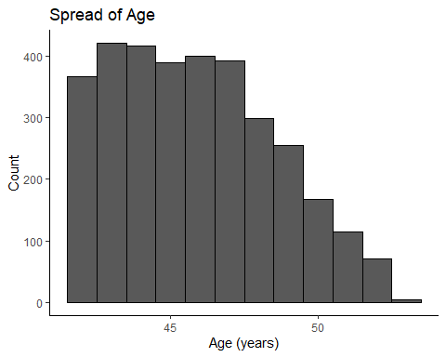

##put a box plot in to highlight the outliers in this chart  
pulse_hist <- ggplot(milestone1_subset,mapping=aes(PULSE0), na.rm = TRUE)+  
 geom_histogram(color="black")+  
 geom_boxplot()+  
 theme_classic()+  
 labs(title="Spread of Pulse", x="Pulse (beats/30 sec)", y="Count")  
pulse_hist

## `stat_bin()` using `bins = 30`. Pick better value with `binwidth`.

## Warning: Removed 7 rows containing non-finite values (stat_bin).

## Warning: Removed 7 rows containing non-finite values (stat_boxplot).

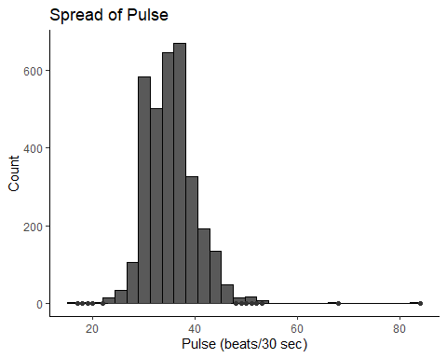

height_hist <- ggplot(milestone1_subset)+  
 geom_histogram(mapping=aes(HEIGHT0), na.rm = TRUE, color="black")+  
 theme_classic()+  
 labs(title="Spread of Height", x="Height (cm)", y="Count")  
height_hist

## `stat_bin()` using `bins = 30`. Pick better value with `binwidth`.

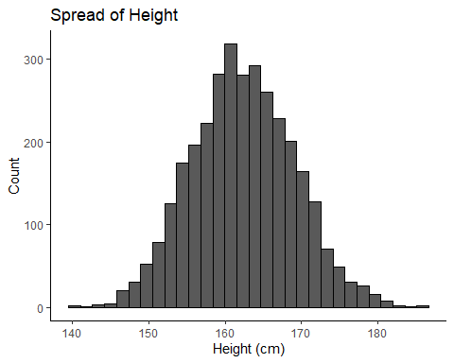

weight_hist <- ggplot(milestone1_subset)+  
 geom_histogram(mapping=aes(WEIGHT0), na.rm = TRUE, color="black")+  
 theme_classic()+  
 labs(title="Spread of Weight", x="Weight (kg)", y="Count")  
weight_hist

## `stat_bin()` using `bins = 30`. Pick better value with `binwidth`.

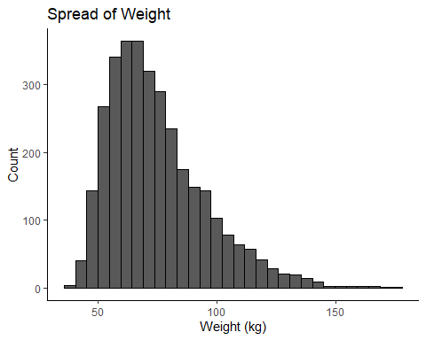

To understand the spread of the categorical data.

##NA's were not being removed with na.rm=TRUE, therefore they were removed before calling the ggplot functions  
anem_freq <- milestone1_subset %>% drop_na() %>%   
 ggplot()+  
 geom_bar(mapping=aes(ANEMIA0))+  
 theme_classic()+  
 labs(title= "Frequency of Patients with Anemia", y= "Count",   
 x="Patients has Anemia")  
anem_freq

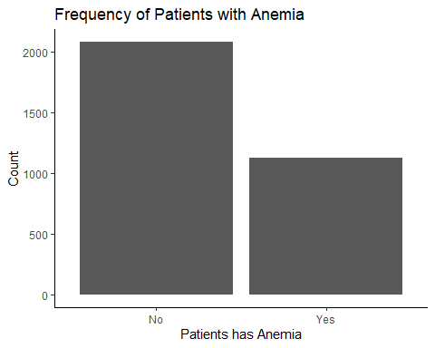

smoke_freq <- milestone1_subset %>% drop_na() %>%   
 ggplot()+  
 geom_bar(mapping=aes(SMOKERE0))+  
 theme_classic()+  
 labs(title= "Frequency of Patients who Smoke", y= "Count",   
 x="Patients who Smoke")  
smoke_freq

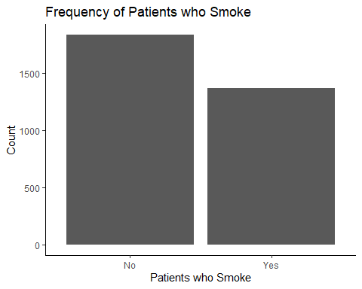

##Analysis of RACE  
ggplot(milestone1_subset)+  
 geom_bar(mapping=aes(RACE))+  
 labs(title="Patient Race")+  
 theme(axis.text.x=element_text(size=13, angle=45, hjust=1, vjust=1))

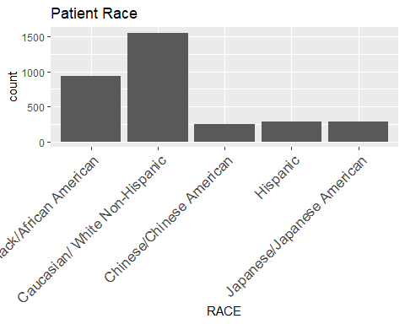

A separate spread analysis for race was necessary because it has multiple possible results.

ggplot(milestone1_subset)+  
 geom_bar(mapping=aes(RACE))+  
 labs(title="Patient Race")+  
 theme(axis.text.x=element_text(size=13, angle=45, hjust=1, vjust=1))



##creating frequency and pareto charts to plot the race data  
##Creates a tibble with the total counts for each race identified  
race <- milestone1_subset %>% group_by(RACE) %>% summarise(Total=n())  
##Calculates the frequency of each race  
race <- mutate(race, Frequency=Total/sum(Total))  
race

## # A tibble: 5 x 3  
## RACE Total Frequency  
## <chr> <int> <dbl>  
## 1 Black/African American 934 0.283   
## 2 Caucasian/ White Non-Hispanic 1552 0.470   
## 3 Chinese/Chinese American 250 0.0757  
## 4 Hispanic 285 0.0863  
## 5 Japanese/Japanese American 281 0.0851

race_pareto <- ggplot(race, mapping=aes(x=RACE, y=Total))+  
 stat_pareto(bars.fill="gray")+  
 labs(title="Patient Race Pareto", x="Race")+  
 theme_classic()+  
 theme(axis.text.x=element_text(size=13, angle=45, hjust=1, vjust=1))  
race_pareto

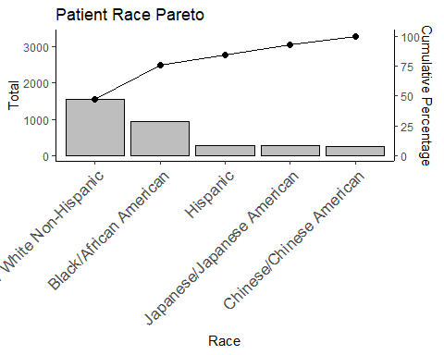

Height and weight relationship using a scatterplot.

hvw_scatter <- ggplot(milestone1_subset)+  
 geom_point(mapping=aes(HEIGHT0, WEIGHT0), na.rm=TRUE, size=0.5)+  
 geom_smooth(mapping=aes(HEIGHT0, WEIGHT0), method=lm, formula=y~x, na.rm=TRUE)+  
 theme_classic()  
hvw_scatter

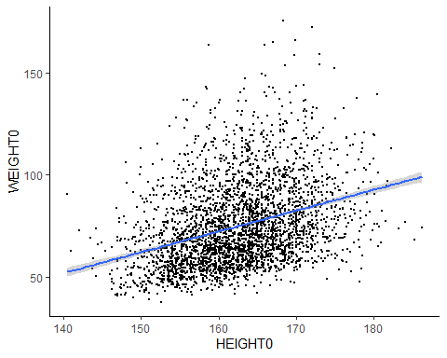

Is there a relationship between race and anemia?

avr_jitter <- milestone1_subset %>% drop_na() %>% ggplot()+  
 geom_jitter(mapping=aes(RACE, ANEMIA0), na.rm=TRUE, size=0.5)+  
 labs(title="Anemia by Race", x="Race", y="Patient had Anemia Diagnosis?")+  
 theme_classic()+  
 theme(axis.text.x=element_text(size=10, angle=75, hjust=1, vjust=1))  
avr_jitter

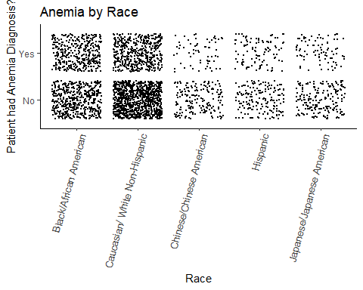

Is there a relationship between smoking and measured pulse?

pulse_density <- milestone1_subset %>% drop_na() %>% ggplot()+  
 geom_density(mapping=aes(PULSE0, color=SMOKERE0), size=1)+  
 theme_classic()+  
 labs(title="Density of Pulse by Smoking Status", x= "Pulse (beats/30 sec)", y="Density")  
pulse_density

